# DAD 220 Cardinality and Targeted Data Template

Replace the bracketed text in this template with your screenshots and responses to the Module Four Lab for submission, grading, and feedback. Screenshots should be sized to approximately one quarter of a page. Written responses should be in complete sentences. Rename this document by adding your last name to the file name before you submit.

1. **Retrieve employee tuples** and **identify the number of employees in San Francisco and New York.**
   1. [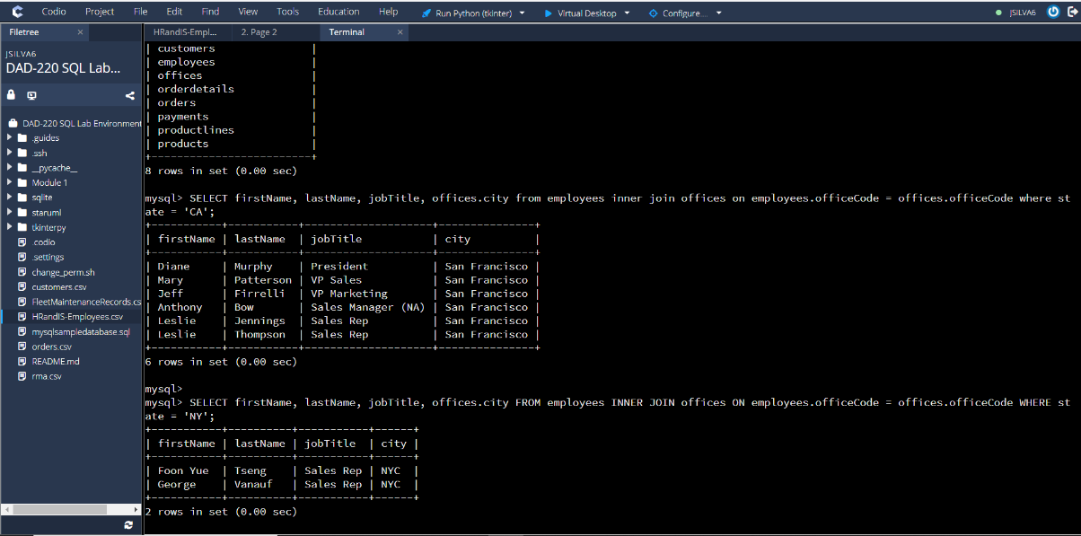]
2. **Retrieve order details** for orderNumber 10330, 10338, and 10194 and **identify what type of cardinality this represents in the entity relationship model.**
   1. [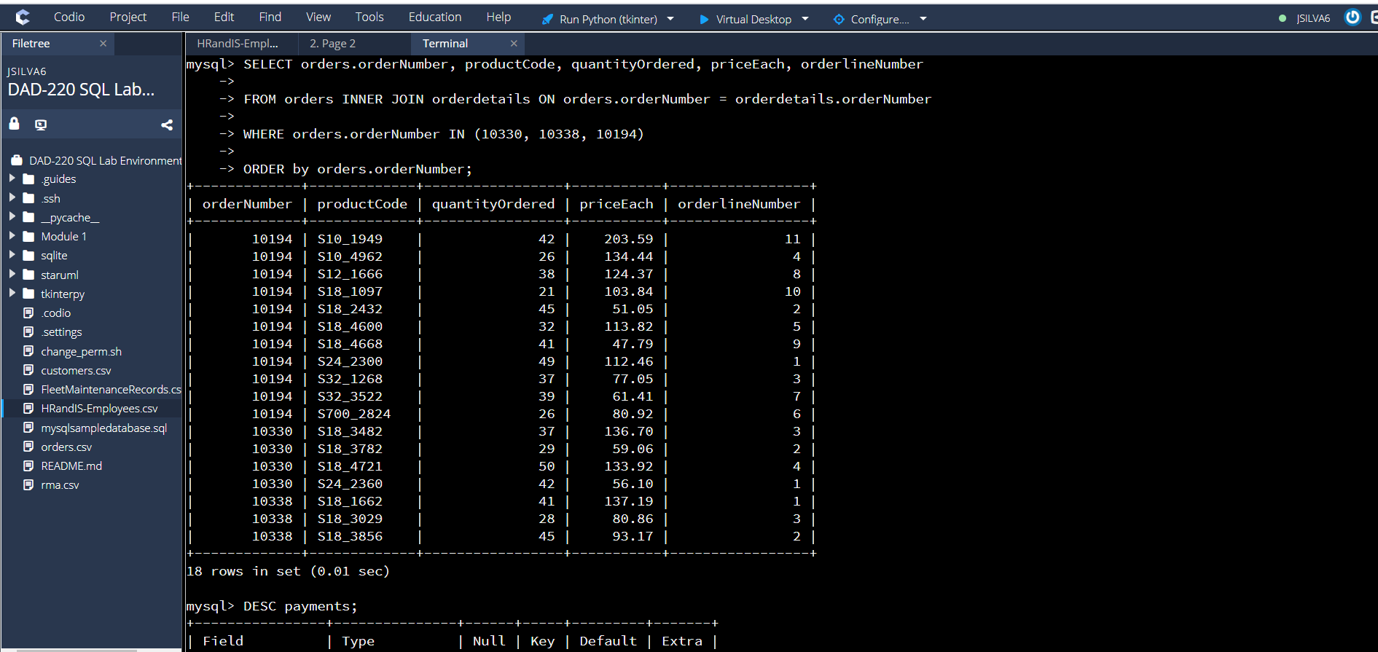]
   2. [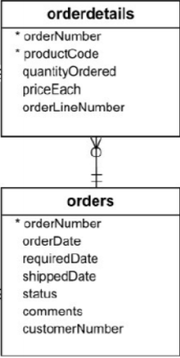]

The cardinality relationship is one-to-many

These symbols mean one (and only one)

The O is optional, and the crow’s foot is many.

1. **Delete records** from the payments table where the customer number equals 103.
   1. [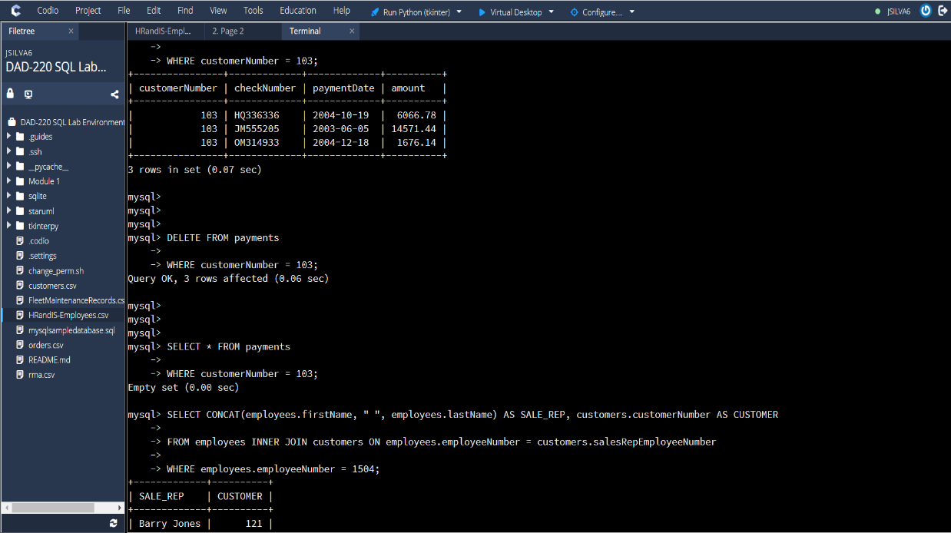]
   2. [Also, in above screenshot.]
2. **Retrieve customer records** for employee Rep Barry Jones and **identify** if the relationships are one-to-one or one-to-many**.**
   1. [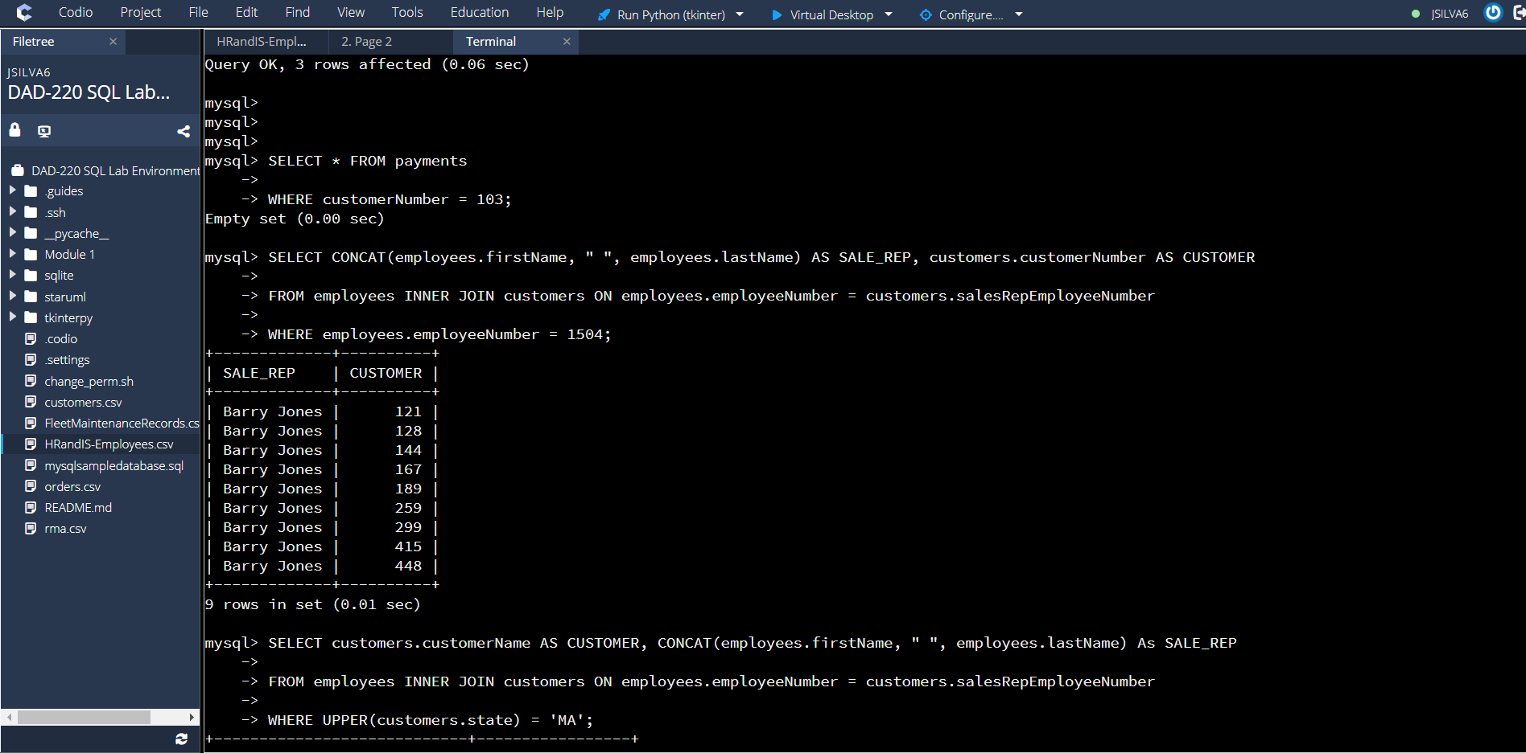]
   2. [This is a one-to-many relationship for sales rep. to customer because the sales rep. (Barry Jones) is one but the sales rep. has many customers. The many customers have one sales rep. (Barry Jones). The ER diagram showed a customer can either zero or one sales rep., but a sale’s rep can have 0 to many customers.]
3. **Retrieve records for customers who reside in Massachusetts** and **identify** their sales rep and if the relationships are one-to-one or one-to-many**.**
   1. [The relationship is one-to-many between the customers in Massachusetts and the sales rep. because each sales rep. has many customers, but a customer only has one sales rep.]
4. Add one customer record with your last name using an INSERT statement. You may use the name of a celebrity or fictional character if you don’t use your own name.
5. [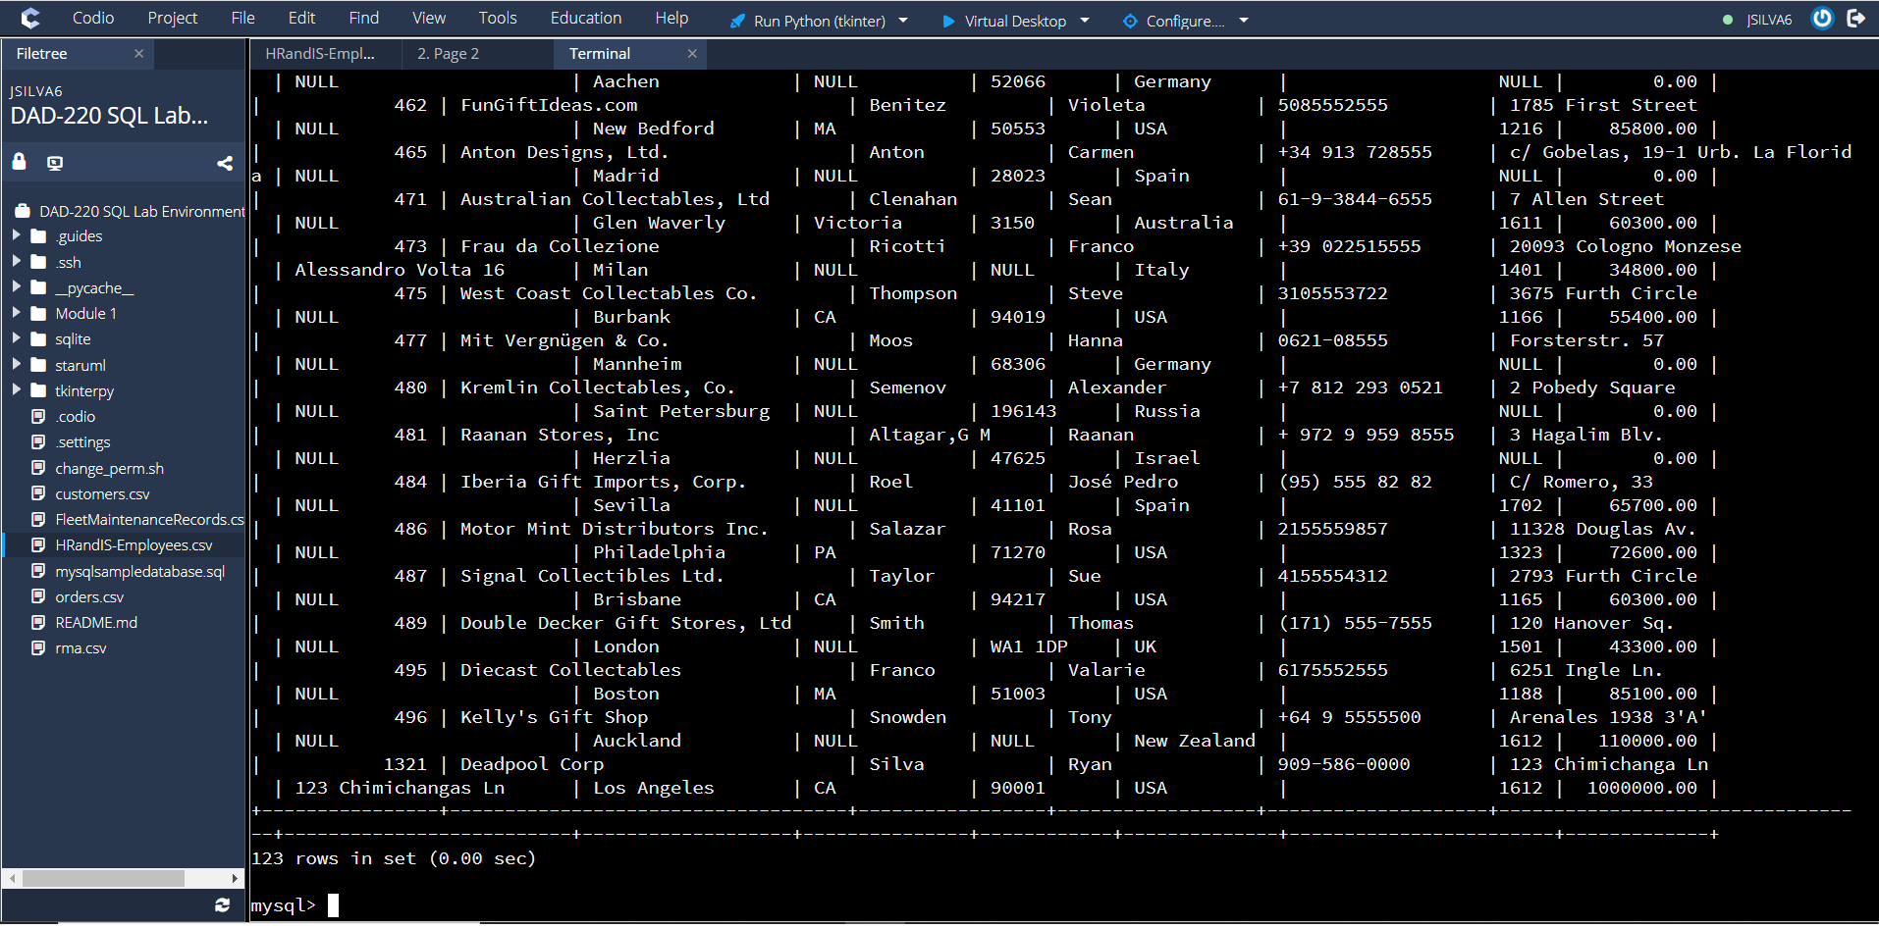]
6. **Reflection**
   1. **Define how cardinality** is applied to the databases you’ve been working with and why different numbers of records returned from the different offices.
      1. [Insert your response here.]
   2. **Compare and contrast** the different queries you ran and how cardinality applies to them.
      1. [Insert your response here.]
   3. **Describe two of the crucial benefits of cardinality** in this type of database.
      1. [Insert your response here.]